Marketing and Sales
Annual Report
June 1, 20XX
The essence of our product line is our dating survey and the specially designed software that matches up clients and generates dating profiles. The survey is taken on-line and when our company receives the results from the clients, we create a file with all respondents’ answers. We then read the file containing all clients’ responses into our software program to find matches.
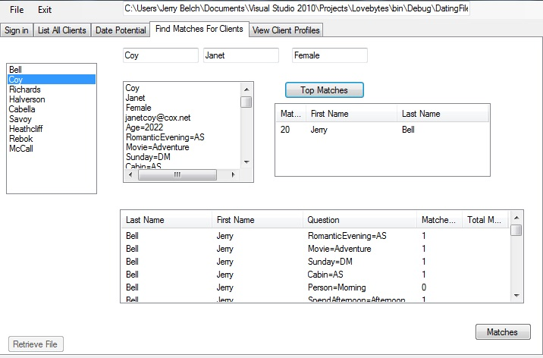

The software also generates profiles of our respondents, which we provide to each client.
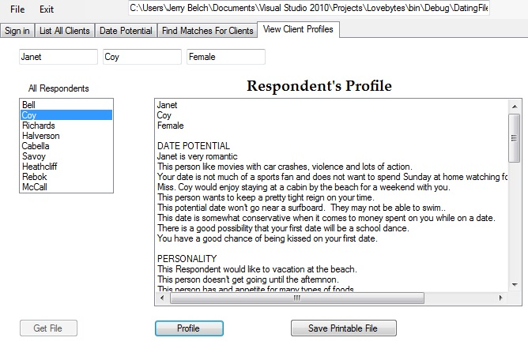
For our first year in operations, the Marketing department did an excellent job of promoting and selling Lovebytes packages. The table below summarizes out sales in each of the items in our product line
Item | Price
One month subscription | $32.95
Six month subscription | $101.70
Deluxe package includes items below | $1,000.00
Tuxedo rental | $200.00
Limousine | $400.00
Corsage | $50.00
Boutonniere | $25.00
Picture package | $292.05

Clients bought 129 of the deluxe packages which includes all items listed in the table above for $1,000.00
We sold 245 of the monthly packages at $32.95
We sold 92 of the six month packages
All packages included matches in the data base and the profiles of those matched.
Our sales were conducted in a number of ways. We had regular monthly open houses, a grand opening, attended three trade shows and sold our service on the Internet through our web page on the Virtual Enterprise shopping mall. We also purchased some advertising space on social media sites and encouraged users to answer our on-line survey for free.
We also had some special promotions on selected high school campuses. To promote our service and get across the idea that computer dating is cool, we auctioned off a deluxe package to a couple who represented the “in-crowd” in one of the top clubs on campus. During trade shows we circulated flyers promoting our product and auctioned off a one month’s subscription
We increased our presence just before major school dances on each campus in our region. Special ads were run in the school newspaper telling them how to go on-line and answer the questionnaire. For the schools that have a TV show where announcements are read, we persuaded them to tell their audience about our service just prior to these dances.

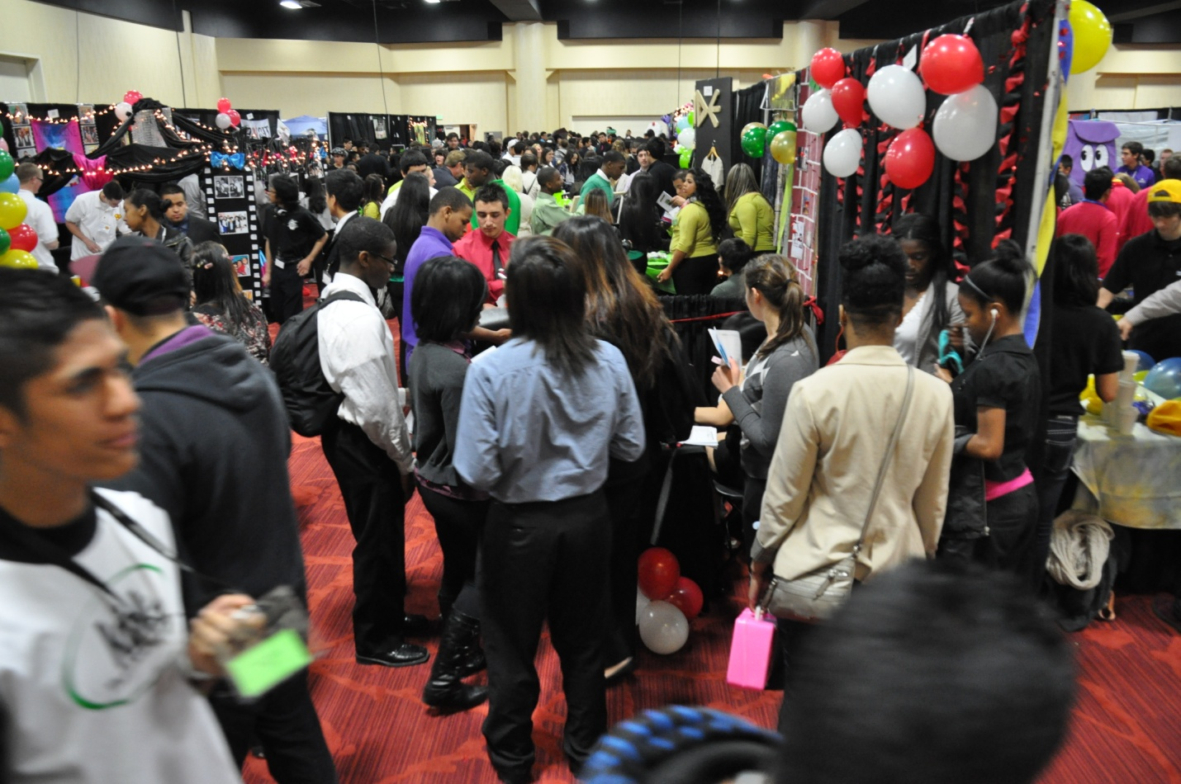
Bay area trade fair March 16, 20XX

